Date : 15.10.2022

Name :Periyannan.P

Roll No :611719104023

# Assignment 3 - Build CNN Model For Classification Of Flowers

1. Unzip dataset

!unzip '/content/Flowers-Dataset.zip'

Archive: /content/Flowers-Dataset.zip



inflating: flowers/daisy/100080576_f52e8ee070_n.jpg inflating: flowers/daisy/10140303196_b88d3d6cec.jpg

inflating: flowers/daisy/10172379554_b296050f82_n.jpg inflating: flowers/daisy/10172567486_2748826a8b.jpg

inflating: flowers/daisy/10172636503_21bededa75_n.jpg inflating: flowers/daisy/102841525_bd6628ae3c.jpg

inflating: flowers/daisy/10300722094_28fa978807_n.jpg

inflating: flowers/daisy/1031799732_e7f4008c03.jpg

inflating: flowers/daisy/10391248763_1d16681106_n.jpg inflating: flowers/daisy/10437754174_22ec990b77_m.jpg inflating: flowers/daisy/10437770546_8bb6f7bdd3_m.jpg inflating: flowers/daisy/10437929963_bc13eebe0c.jpg

inflating: flowers/daisy/10466290366_cc72e33532.jpg inflating: flowers/daisy/10466558316_a7198b87e2.jpg inflating: flowers/daisy/10555749515_13a12a026e.jpg inflating: flowers/daisy/10555815624_dc211569b0.jpg

inflating: flowers/daisy/10555826524_423eb8bf71_n.jpg inflating: flowers/daisy/10559679065_50d2b16f6d.jpg

inflating: flowers/daisy/105806915_a9c13e2106_n.jpg inflating: flowers/daisy/10712722853_5632165b04.jpg inflating: flowers/daisy/107592979_aaa9cdfe78_m.jpg

inflating: flowers/daisy/10770585085_4742b9dac3_n.jpg inflating: flowers/daisy/10841136265_af473efc60.jpg

inflating: flowers/daisy/10993710036_2033222c91.jpg

inflating: flowers/daisy/10993818044_4c19b86c82.jpg inflating: flowers/daisy/10994032453_ac7f8d9e2e.jpg inflating: flowers/daisy/11023214096_b5b39fab08.jpg

inflating: flowers/daisy/11023272144_fce94401f2_m.jpg inflating: flowers/daisy/11023277956_8980d53169_m.jpg inflating: flowers/daisy/11124324295_503f3a0804.jpg

inflating: flowers/daisy/1140299375_3aa7024466.jpg inflating: flowers/daisy/11439894966_dca877f0cd.jpg

inflating: flowers/daisy/1150395827_6f94a5c6e4_n.jpg inflating: flowers/daisy/11642632_1e7627a2cc.jpg

inflating: flowers/daisy/11834945233_a53b7a92ac_m.jpg

inflating: flowers/daisy/11870378973_2ec1919f12.jpg

inflating: flowers/daisy/11891885265_ccefec7284_n.jpg inflating: flowers/daisy/12193032636_b50ae7db35_n.jpg inflating: flowers/daisy/12348343085_d4c396e5b5_m.jpg inflating: flowers/daisy/12585131704_0f64b17059_m.jpg inflating: flowers/daisy/12601254324_3cb62c254a_m.jpg inflating: flowers/daisy/1265350143_6e2b276ec9.jpg



inflating: flowers/daisy/12701063955_4840594ea6_n.jpg inflating: flowers/daisy/1285423653_18926dc2c8_n.jpg inflating: flowers/daisy/1286274236_1d7ac84efb_n.jpg inflating: flowers/daisy/12891819633_e4c82b51e8.jpg

inflating: flowers/daisy/1299501272_59d9da5510_n.jpg inflating: flowers/daisy/1306119996_ab8ae14d72_n.jpg inflating: flowers/daisy/1314069875_da8dc023c6_m.jpg inflating: flowers/daisy/1342002397_9503c97b49.jpg

inflating: flowers/daisy/134409839_71069a95d1_m.jpg inflating: flowers/daisy/1344985627_c3115e2d71_n.jpg

inflating: flowers/daisy/13491959645_2cd9df44d6_n.jpg inflating: flowers/daisy/1354396826_2868631432_m.jpg inflating: flowers/daisy/1355787476_32e9f2a30b.jpg

inflating: flowers/daisy/13583238844_573df2de8e_m.jpg inflating: flowers/daisy/1374193928 a52320eafa.jpg

# Importing Necessary Libraries

import warnings

warnings.filterwarnings("ignore")

import numpy as np

import matplotlib.pyplot as plt import pandas as pd

from tensorflow.keras.models import Sequential

from tensorflow.keras.layers import Dense,Activation,Dropout,Conv2D,Flatten,MaxPool2D,Resh from tensorflow.keras.applications.resnet50 import ResNet50

from tensorflow.keras.applications.resnet50 import preprocess_input from tensorflow.keras.preprocessing import image

from tensorflow.keras.preprocessing.image import ImageDataGenerator,load_img,img_to_array from tensorflow.keras.callbacks import EarlyStopping, ReduceLROnPlateau

# Image Augumentation

Dataset consist of 5 classes.

**Daisy** - European Species of Aster family.

**Sunflower** - Identified as the genus of Helianthus.

**Tulip** - It belongs to the species of spring blooming geophytes.

**Rose** - It belongs to the family of rosaceae.

**Dandelion** - Indentifies as the genus of Asterceae.

path = 'flowers/'

train_data_gen = ImageDataGenerator(rescale = 1./255,

shear_range = 0.2,

zoom_range = 0.2,

horizontal_flip = True, validation_split = 0.30)

test_data_gen = ImageDataGenerator(rescale = 1./255,validation_split = 0.30)

training_set = train_data_gen.flow_from_directory(path,

target_size=(64,64), batch_size=100,

class_mode='categorical', shuffle=True,

color_mode='rgb',

subset = 'training')

testing_set = test_data_gen.flow_from_directory(path,

target_size=(64,64), batch_size=100,

class_mode='categorical', shuffle=True,

color_mode='rgb',

subset = 'validation')

Found 3024 images belonging to 5 classes. Found 1293 images belonging to 5 classes.

# Create the model

model = Sequential()

# Add Layers (Convolution,MaxPooling,Flatten,Dense- Hidden Layers,Output)

#convolution and Pooling layer 1

model.add(Conv2D(filters=48,kernel_size=3,activation='relu',input_shape=(64,64,3))) model.add(MaxPool2D(pool_size=2,strides=2))

model.add(Dropout(0.2))

#convolution and Pooling layer 2

model.add(Conv2D(filters=32,kernel_size=3,activation='relu')) model.add(MaxPool2D(pool_size=2,strides=2))

model.add(Dropout(0.2))

#Flattening the images model.add(Flatten())

#Fully Connected layers

model.add(Dense(64,activation='relu')) model.add(Dropout(0.2))

model.add(Dense(5,activation='softmax')) model.summary()

Model: "sequential"

Layer (type) Output Shape Param #

=================================================================

|  |  |  |  |  |
| --- | --- | --- | --- | --- |
| conv2d (Conv2D) | (None, 62, 62, 48) | | | 1344 |
| max_pooling2d (MaxPooling2D | (None, 31, 31, 48) | | | 0 |
| ) |  | | |  |
| dropout (Dropout) | (None, 31, 31, 48) | | | 0 |
| conv2d_1 (Conv2D) | (None, 29, 29, 32) | | | 13856 |
| max_pooling2d_1 (MaxPooling 2D) | (None, 14, 14, 32) | | | 0 |
| dropout_1 (Dropout) | (None, | 14, 14, | 32) | 0 |
| flatten (Flatten) | (None, | 6272) |  | 0 |
| dense (Dense) | (None, | 64) |  | 401472 |
| dropout_2 (Dropout) | (None, | 64) |  | 0 |
| dense_1 (Dense) | (None, | 5) |  | 325 |

=================================================================

Total params: 416,997

Trainable params: 416,997

Non-trainable params: 0

# Compiling the Model

model.compile(loss='categorical_crossentropy',optimizer='adam',metrics=['accuracy'])

# Fitting the Model

early_stop = EarlyStopping(monitor='val_accuracy',

patience=5,verbose=1,mode='auto')

lr = ReduceLROnPlateau(monitor='val_accuracy',

factor=0.2,patience=5, min_lr=0.00001)

callback = [early_stop,lr]

Training the Model

result = model.fit(x=training_set, validation_data=testing_set, epochs=10)

|  |  |  |  |  |  |  |  |  |
| --- | --- | --- | --- | --- | --- | --- | --- | --- |
| Epoch  31/31 | 1/10  [==============================] | - 30s | | 966ms/step | - loss: | 0.7625 | - accuracy: | 0 |
| Epoch | 2/10 |  | |  |  |  |  |  |
| 31/31  Epoch 31/31 | [==============================] 3/10  [==============================] | - 30s  - 31s | | 969ms/step  985ms/step | * loss: * loss: | 0.7454  0.7348 | * accuracy: * accuracy: | 0  0 |
| Epoch  31/31 | 4/10  [==============================] | - 30s | | 968ms/step | - loss: | 0.7144 | - accuracy: | 0 |
| Epoch | 5/10 |  | |  |  |  |  |  |
| 31/31  Epoch | [==============================]  6/10 | - 31s | | 992ms/step | - loss: | 0.7233 | - accuracy: | 0 |
| 31/31  Epoch | [==============================] 7/10 | - | 32s | 1s/step - loss: 0.7017 - accuracy: 0.73 | | | | |
| 31/31 | [==============================] | - 30s | | 963ms/step | - loss: | 0.6715 | - accuracy: | 0 |
| Epoch  31/31 | 8/10  [==============================] | - 31s | | 978ms/step | - loss: | 0.6512 | - accuracy: | 0 |
| Epoch | 9/10 |  | |  |  |  |  |  |
| 31/31  Epoch 31/31 | [==============================] 10/10  [==============================] | - 31s  - 30s | | 982ms/step  974ms/step | * loss: * loss: | 0.6711  0.6481 | * accuracy: * accuracy: | 0  0 |

Loss and Accuracy check using plot

#plot the loss

plt.plot(result.history['loss'], label='train loss')

plt.plot(result.history['val_loss'], label='val loss') plt.legend()

plt.show()

# plot the accuracy

plt.plot(result.history['accuracy'], label='train acc') plt.plot(result.history['val_accuracy'], label='val acc') plt.legend()

plt.show()

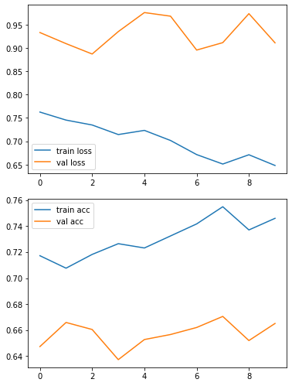

7. Saving the Model

model.save('daisy.h5')

8. Testing the Model

training_set.class_indices

classes = ['Daisy','Dandelion','Rose','Sunflower','Tulip'] def testing(img):

img = image.load_img(img,target_size=(64,64)) x = image.img_to_array(img)

x = np.expand_dims(x,axis=0)

pred = np.argmax(model.predict(x))

return print("Predicted class as:",classes[pred])

def img_show(img):

img1 = image.load_img(img,target_size=(64,64)) plt.imshow(img1)

#test1

img_show('/content/flowers/sunflower/12471443383_b71e7a7480_m.jpg') testing('/content/flowers/sunflower/12471443383_b71e7a7480_m.jpg')

Predicted class as: Sunflower

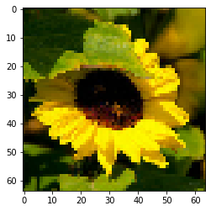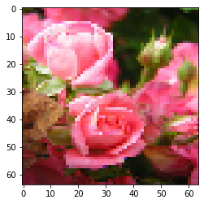

#test2

img_show('/content/flowers/rose/323872063_7264e7e018_m.jpg') testing('/content/flowers/rose/323872063_7264e7e018_m.jpg')

Predicted class as: Rose

#test3

img_show('/content/flowers/dandelion/2116997627_30fed84e53_m.jpg') testing('/content/flowers/dandelion/2116997627_30fed84e53_m.jpg')

Predicted class as: Daisy

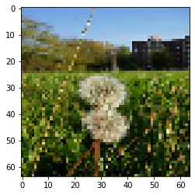

#test4

img_show('/content/flowers/daisy/1314069875_da8dc023c6_m.jpg') testing('/content/flowers/daisy/1314069875_da8dc023c6_m.jpg')

Predicted class as: Daisy

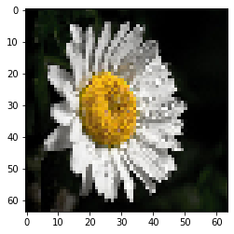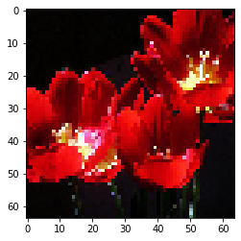

#test5

img_show('/content/flowers/tulip/132538273_335240fe5b_n.jpg') testing('/content/flowers/tulip/132538273_335240fe5b_n.jpg')

Predicted class as: Tulip

**Conclusion:**

**The dataset has about 4317 images from 5 different classes.**

* 1. Each classes have more than 500 images for training the data.
  2. 30% of the data taken for validation.
  3. The accuracy of the model is around 80%.
  4. The validation accuracy is around 70%.
  5. The model is built with 2 layered convolutional network considering 1344 trainable parameters.
  6. Testing the model with unknown images gives 95% accuracy.